Byron Central Hospital

Wayfinding Action Plan
February 2017

Good wayfinding means knowing where you are, knowing where you are going to, following the
best route to your destination and recognising it on arrival. Wayfinding is more than just signs:
it is a co-ordinated group of aids to help people navigate.
Wayfinding for Healthcare Facilities, NSW Health 2014

Recent walkthroughs with consumers at the new Byron Central Hospital have identified a number of difficulties with navigation of the site. The walkthroughs asked people to undertake a ‘common journey’, for example, visiting a patient or attending a dental appointment. This plan contains a summary of the most pressing of these, along with recommendations to address the identified areas of concern.

Recommendation 1: Vehicle navigation
Time frame: Immediate
Vehicle navigation is the first priority area identified as a current safety risk. Drivers turn off the busy roundabout into a large road space, with no clear road markings, three directional options and complicated signage. This leads to a dangerous hesitation while people have to make a quick choice to work out where they need to go.
- Main directional sign – This needs to be simplified and no more than three options placed on a clear high contrast sign with much larger text (see example). This should be located at the far western corner of the car park, closer to the road that travels straight ahead. This will make the ‘straight ahead’ arrows make sense. Currently they point into the car park.
- Signs are all one neutral grey tone and do not stand out from lamp posts.
- Painted sign on road is too close to road. No time for drivers to read it.

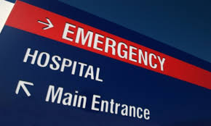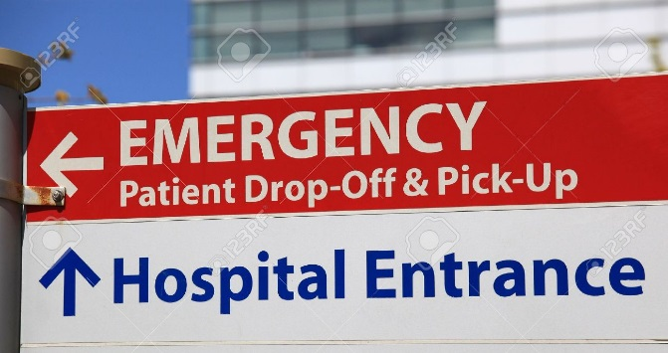

Recommendation 2: Pedestrian Access
Time frame: Immediate

Pedestrian access is the second priority area identified as a safety hazard for people arriving at the site for the following reasons;
- There is no defined path from the site entrance to the Main Entrance for people who arrive by car.
- People are not using the pedestrian walkway from the car park. Instead, most people take the most direct route through the garden.
- People who walk from town are also attempting to enter the hospital via the Ambulance exit gate and becoming stuck as there is no access at the back of the hospital.

“People take the shortest or most direct route regardless of defined pathways.”

- Add a walkway through the garden along the most common route.
- Add new sign at exit to Ambulance station indicating where the main entrance is located “No access to hospital. Main Entrance 100m (directional arrow) ”. Also add pedestrian crossing across this entrance to guide people straight on rather than into the back car park.

- Add pedestrian crossing from street across ambulance bay entrance and exit to guide pedestrians as well as alert vehicles. Tactile Ground Surface Indicators may also be considered. These provide a tactile surface on public pathways and access routes that can be felt underfoot and recognised as a warning of impending pedestrian hazard, particularly to the vision impaired, but also as an added safety precaution to all pedestrians.
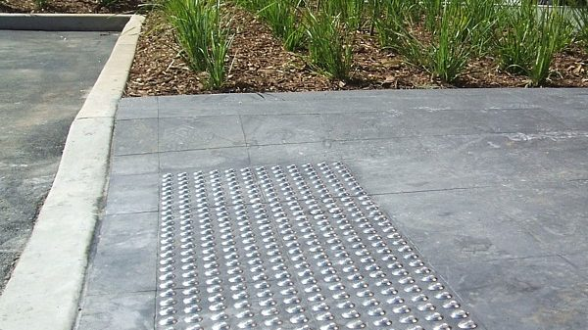

Recommendation 3: Terminology and Interior signage
Time frame: Immediate
Interior signage is not always helpful for wayfinding, and some terms used are confusing or not consistent with where people have been told to present. For example, many people are told to visit Community Health, but when they arrive there is no area called Community Health.
- Use consistent terminology (online says Dental but all the signs on site say ‘Oral health’)
- Add ‘/’ and additional term to help remove confusion on existing signs:
  - Oral Health / Dental
  - Inpatients Unit / Ward
  - Harm Minimisation / Needle Exchange (and use the universal symbol)
  - Ambulatory care / Community Health
  - Gym / Physiotherapy
  - What is an ambulant toilet?
- Destination signs in Ambulatory Care that are in a larger font on a high contrast background to be placed at the edge of the entry so people can clearly see they are on the right path as they travel down the long corridor. Text is located at the left hand side of the sign (not in the centre) so that it can be read as people approach.
- Front toilets need sign at top that is set at 90 degrees from wall to show Ladies/Mens/Accessible/ Baby Change.
- Suggest to remove first sign immediately above front entrance inside doors as information is repeated on second sign that is visible from here and a site map will be available.
- Once signage reviewed and changes in place, remove the A-frame sign that has been placed near reception.

Recommendation 4: Main entrance and reception
Time frame: Ongoing
Many people find main entrance sign too small and difficult to see from site entry. Enhancing other directional signage may aid in finding the entrance.
- Reception desk can have added sign set at 90 degrees to wall with the universal ‘Information’ symbol (a lower case ‘i’). Also a sign at same angle to indicate that Community Health patients should report to reception. This could be a small A Frame notice that sits on the desk.

Recommendation 5: Site Map
Time frame: Ongoing
The site map is not positioned in a central location and many people miss it. It is not easy to see where entrances are on the site map.
- Add site map inside entrance on left hand side so people step out of the way to view it.
- Make site map available online.
- Indicate ‘Entry’ on site map in different colour or different style to destinations.
Recommendation 6: Deliveries
Time frame: Ongoing
- Add signage or ground markings to indicate to drivers where they can park or unload.
- Add sign for delivery drivers at back gate.

Recommendation 7: Mental Health Unit
Time frame: Long term

- Providing a name for the Mental Health Inpatient Unit will help people find it e.g. The Buttery, Tarmons House. Currently there is no signage at the entrance to suggest people have arrived at their destination. It is understood that we wish to avoid the stigma of labelling this ‘Mental health’ however this name is on lots of other signs throughout the facility. Community consultation could help come up with a name that is relevant for the local community and can be used in all signage throughout the facility.
Recommendation 8: Landmarks
Time frame: Long term

- Murals and artworks can help designate where things are, and help people create a mental map. The current artworks on display could be utilised or augmented to aid with navigation e.g. “Dental is on the right, just past the whale painting”.
- A landmark could also be a solution to find mental health. For example, a sculpture/potted plant/mural could help when explaining where it is. This could always be linked to a name e.g. Dolphin House and a dolphin sculpture/mural.

Other feedback that is worth monitoring includes:
- Disability parking – only 2 places and this is not sufficient
- Signage on Ewingsdale road to say ‘Hospital, turn left 100 metres
- More buses would be helpful for those relying on public transport

Byron Central Hospital Walkability Action Plan
Issue \ Priority | Action | Update | Who | When
- Vehicle access  Immediate | Directional signage at entrance from road to be reviewed. A larger main directional sign to be put in place (This needs to be simplified and no more than three options placed on a clear high contrast sign with much larger text. This should be located at the far western corner of the car park, closer to the road that travels straight ahead. This will make the ‘straight ahead’ arrows make sense. Currently they point into the car park) | Independent report by Institute of Road Maintenance was conducted and recommendations tabled and to be considered | Keryn York, Director of Nursing, Byron Central Hospital. | Report completed March 2017 Recommendations ongoing
 | Existing signs and new signs to be contrasting colours so as to stand out | As above
 | Painted sign on road to be reviewed and options that are more visible to be explored. | As above
- Pedestrian Access  Immediate | Add a walkway through the garden along the most common route. | Not considered best option | Keryn York, Director of Nursing, Byron Central Hospital. | As above
 | Add new sign at exit to Ambulance station indicating where the main entrance is located “No access to hospital. Main Entrance 100m (directional arrow)”. Also add pedestrian crossing across this entrance to guide people straight on rather than into the back car park. | Pedestrian access is to be considered as part of main vehicle access (see above)
 | Add pedestrian crossing from Ewingsdale road across ambulance bay entrance\ exit to guide pedestrians as well as alert vehicles.  Consider tactile Ground Surface Indicators to guide and as an added safety precaution to all pedestrians. | Pedestrian access is to be considered as part of main vehicle access (see above)
 | Consider planting the existing garden bed with hedge to stop pedestrians walking through garden and to force them to use the crossing | Garden beds planted in May 2017 | Keryn York, Director of Nursing, Byron Central Hospital. | Completed
- Terminology \ interior signage  Immediate | Check terminology so it is consistent across all mediums e.g. online says Dental but all the signs on site say ‘Oral health’ | Please see independent document on Signage which details all changes to be made | Maxine Molyneux, Health Promotion Officer, to develop doc.  Keryn to approve changes. | Doc completed July 2017  Signs Completed August 2017
 | Add ‘/’ and additional term to help remove confusion on existing signs:  o Oral Health / Dental  o Inpatients Unit / Ward  o Harm Minimisation / Needle Exchange (+ symbol)  o Ambulatory care / Community Health  o Gym / Physiotherapy  o Re-word ambulant toilet to user friendly language | Please see independent document on Signage which details all changes to be made | Maxine Molyneux, Health Promotion Officer, to develop doc.  Keryn to approve changes. | Doc completed July 2017  Signs Completed August 2017
 | Install destination signs in Ambulatory Care Unit (in a larger font on a high contrast background and placed at the edge of the entry so people can clearly see as they travel down the long corridor.  Locate text on the left hand side of the sign (not in the centre) so that it can be read as people approach. | Please see independent document on Signage which details all changes to be made | Maxine Molyneux, Health Promotion Officer, to develop doc.  Keryn to approve changes. | Doc completed July 2017  Signs Completed August 2017
 | Remove first sign above front entrance doors (inside) | Please see independent document on Signage which details all changes to be made | Maxine Molyneux, Health Promotion Officer, to develop doc.  Keryn to approve changes. | Doc completed July 2017  Signs Completed August 2017
 | Install signs at Front toilets set at 90 degrees from wall to show Ladies/Mens/Accessible/ Baby Change | Please see independent document on Signage which details all changes to be made | Maxine Molyneux, Health Promotion Officer, to develop doc.  Keryn to approve changes. | Doc completed July 2017  Signs Completed August 2017
- Main Entrance \ Reception | Add sign at reception desk set at 90 degrees to wall with the universal ‘Information’ symbol (a lower case ‘i’). | Please see independent document on Signage which details all changes to be made | Maxine Molyneux, Health Promotion Officer, to develop doc.  Keryn to approve changes. | Doc completed July 2017  Committee decided against this one
 | Add sign at reception (could be at 90-degree angle) to indicate that Community Health patients should report to reception. | Please see independent document on Signage which details all changes to be made | Maxine Molyneux, Health Promotion Officer, to develop doc.  Keryn to approve changes. | Doc completed July 2017  Committee decided against this one
 | Consider adding ‘please report to reception upon arrival’ to the text message Community Health clients receive to confirm their appointments. | Please see independent document on Signage which details all changes to be made | Maxine Molyneux, Health Promotion Officer, to develop doc.  Keryn to approve changes. | Doc completed July 2017  Committee decided against this one
- Site Map | Add site map inside entrance on left hand side so people step out of the way to view it. Alternatively, it could be located on the outside of the main entrance doors. | Please see independent document on Signage which details all changes to be made | Maxine Molyneux, Health Promotion Officer, to develop doc.  Keryn to approve changes. | Doc completed July 2017  Signs Completed August 2017
 | Make site map available online. | Please see independent document on Signage which details all changes to be made | Maxine Molyneux, Health Promotion Officer, to develop doc.  Keryn to approve changes. | Doc completed July 2017
 | Indicate ‘Entry’ on site map in different colour or different style to destinations. | Please see independent document on Signage which details all changes to be made | Maxine Molyneux, Health Promotion Officer, to develop doc.  Keryn to approve changes. | Doc completed July 2017  Signs Completed August 2017
- Deliveries | Add signage or ground markings to indicate to drivers where they can park or unload. | Please see independent document on Signage which details all changes to be made | Maxine Molyneux, Health Promotion Officer, to develop doc.  Keryn to approve changes. | Doc completed July 2017  Signs Completed August 2017
 | Add sign for delivery drivers at back gate. | Please see independent document on Signage which details all changes to be made | Maxine Molyneux, Health Promotion Officer, to develop doc.  Keryn to approve changes. | Doc completed July 2017  Signs Completed August 2017
- Signage at Mental Health Unit | Consider appropriate signage for this unit. Providing a name | Please see independent document on Signage which details all changes to be made | Maxine Molyneux, Health Promotion Officer, to develop doc.  Keryn to approve changes. | Doc completed July 2017  Signs Completed August 2017
- Landmarks | Look for opportunities to use Landmarks as guiding factors and a way of describing access to points around the site | Will take into consideration

